Week 5 – The Operational Data Store

This week we explore the Operational Data Store or (ODS). The ODS is a topic of great debate within data warehousing. Inmon describes the ODS as a subject-oriented, integrated, current, volatile collection of data used to support operational functions. In this model, the ODS is optional and it never resides in the data warehouse. It allows for the updating of data, and is focused on current information. A standard given is around a month’s worth of data, and it would rarely contain historical information. The ODS may be sourced from the data warehouse or another system. Organizations may have multiple ODS in place.

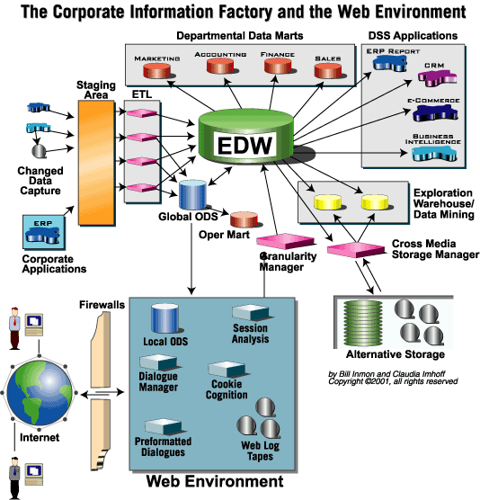

In contrast, Kimball views the ODS as simply a part of the data warehouse. He notes that earlier data warehousing designs had a separate ODS between the transactional system and the warehouse. Often this served as a staging area, and was not used for querying. As information needs have changed, the requirement to query this detailed data has become more important for the warehouse consumer. It has resulted in the merging of the ODS with the staging area of the warehouse. His view is that the ODS is an integral part of the overall warehouse design.

These opposing views mirror the two different models for data warehousing. From the previous discussions, remember that Inmon’s design requires that the atomic data is stored in a normalized format. The CIF views the data warehouse as a component of a larger design. Kimball’s design requires that atomic data be dimensionally structured. It views the entire structure as the data warehouse. Understanding the way in which these two designs define the data warehouse is key to their position on the ODS.

This week’s topic will explore the role of an ODS in detail. It will include an analysis of an organizational need, in order to recommend a strategy that could be used in a data warehouse design. This will be a key component of the final project.

This week’s reading will be Inmon’s text Chapter 16 and Kimball Reader pages 226-228 and 606-610. Pay particular attention to the way both thought leaders view the need to dimensionalize data, and what layer the suggest you do that in.

Depending on which approach, the ODS can be optional (or viewed simply as a component of an overall data warehouse). Within the ODS design, both designs have different aspects. For example, Inmon mentions four classes that reflect refresh frequencies. Each organizational context will present its own need for refresh. This will be a key question in your final action plan at the end of the course. In the assignment this week, you will continue to explore the need to include this element in your final design. Depending on which approach you select, it will determine the need and design of your ODS.

Please remember the general forum rules on posting. If you have any questions about the assignment, please post in the weekly thread.